 | Qatar University  College of Engineering  Department of Computer Science and Engineering

CMPE263 Computer Architecture and Organization I
Course Project Report
Spring 2024

Project Title

Design of 7-bit CPU using Logisim by integrating ALU, Registers and ROM

Submitted By:
Mohammad Ahmad – 202002453

Table of Contents
Part I: Introduction 3
Part II: CPU Architecture and Organization 3
Part III: Instruction Set 3
Part IV: Instruction Format ………………………………………………………………………………………………………………………………..3
Part V: Assembly Programs 3
Part VI: Conclusion 3

Part I: Introduction
The general concept of this design is that the CPU receives some instructions that are coded in hexadecimal, each set has 4 hex-digits. These are then broken down into individual bits and used appropriately in order to execute tasks in the CPU and perform the desired actions. The constraint for this design is the number of bits stored at one memory address (16 bits ranging from 0 to 15), this limits how complex the CPU operations can get.

Part II: CPU Architecture and Organization
Below is a screenshot of the overview of the proposed CPU architecture (individual parts will be discussed in full).
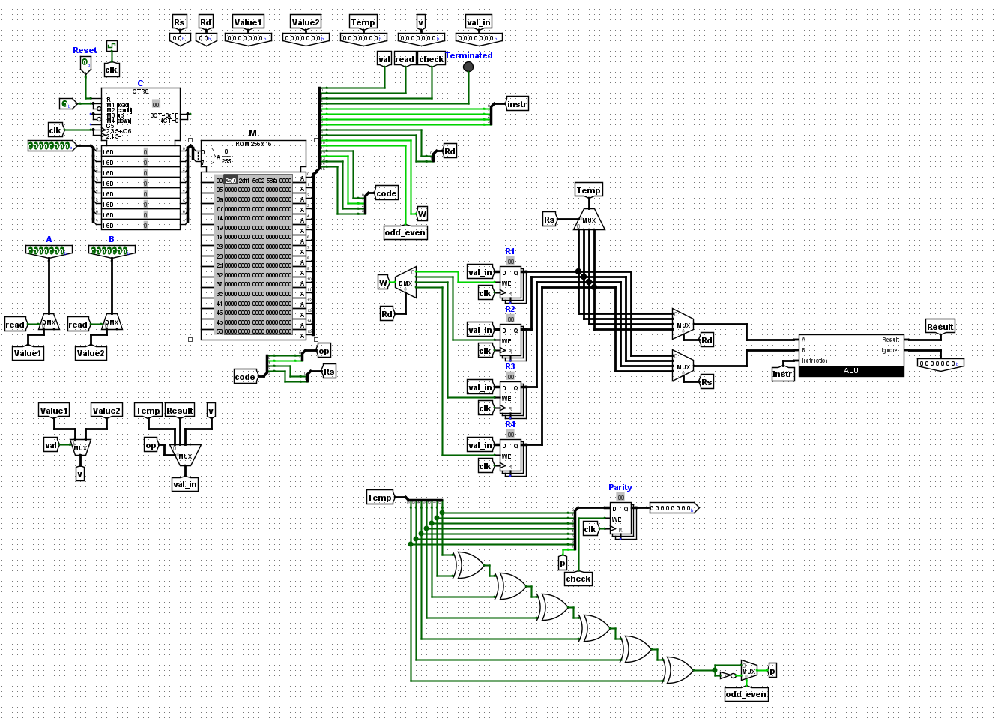

Please note that the top set of tunnels and outputs have only been placed for debugging purposes and do not serve any real purpose for the function of this CPU.
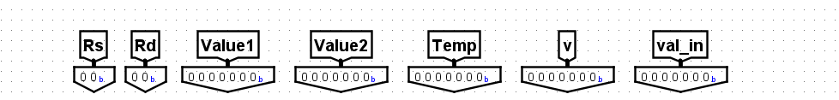

The user may enter values A and B for testing purposes here. Please note that for programs where a single value is required as an input, the value is read from input A.
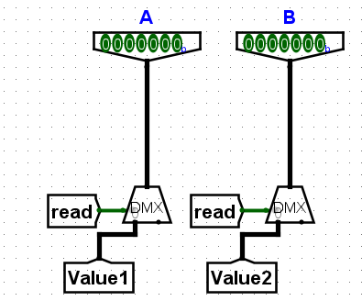

This is the program counter linked with the 8-bit addressable memory. A clock as been attached to a tunnel and will be used in various parts of the CPU. One of such tunnels is attached to the program counter. The counter is set up in such a way that it moves to the next address in the memory at each clock cycle’s rising edge.
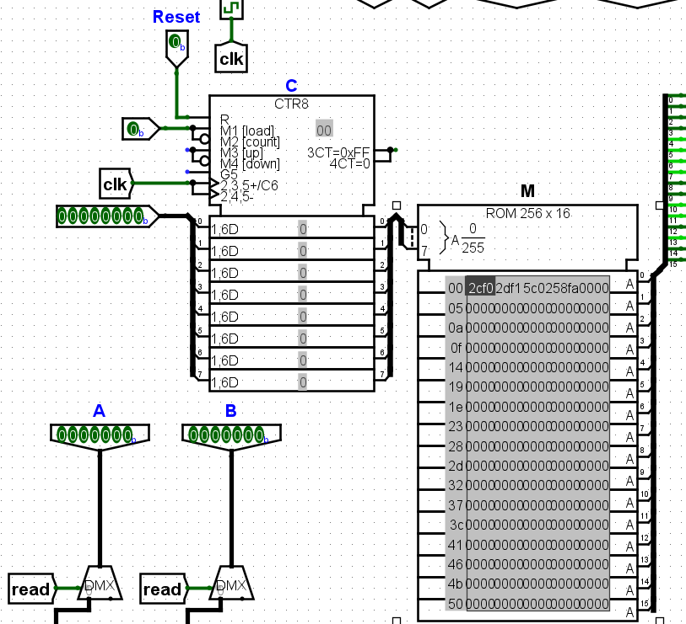

The address that is read from memory is interpreted in the following way:
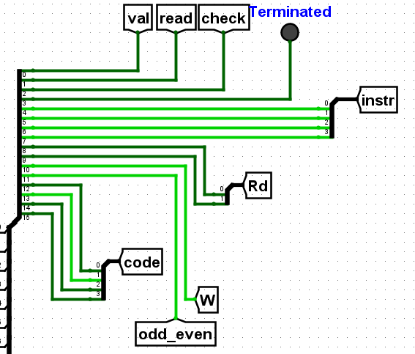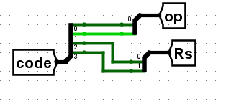
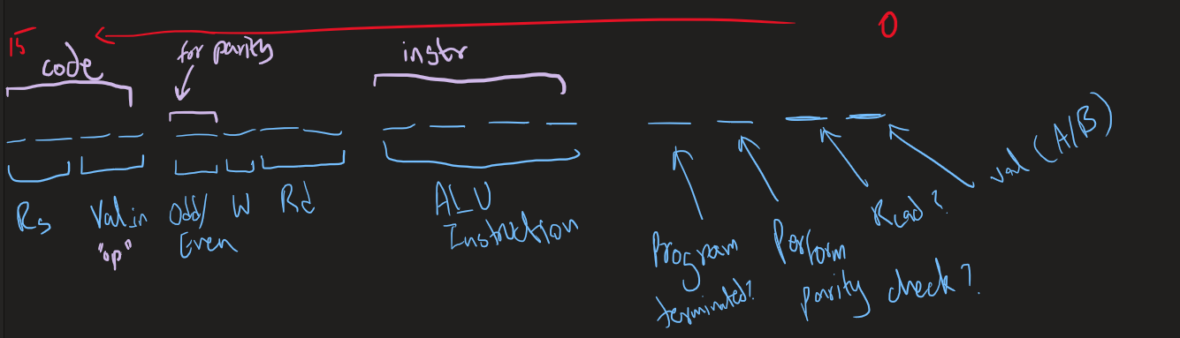

The input and written values are controlled by the following MUX setups:
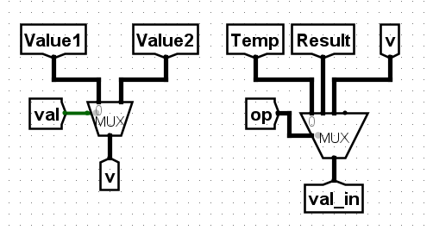
(Here, “val_in” is the value that will be written to a register)

The register bank setup is linked directly with the ALU. For transferring values from one register to another, a value reading setup was implemented which stores the value of the desired register in the “Temp” tunnel. The MUXs read values from “Rd” and “Rs” respectively and feed them to the ALU to perform the desired operations whenever desired. The ALU may give out a result if the operation was required. If not, then it simply offloads the result to an ignore output (implemented as an output for debugging reasons)
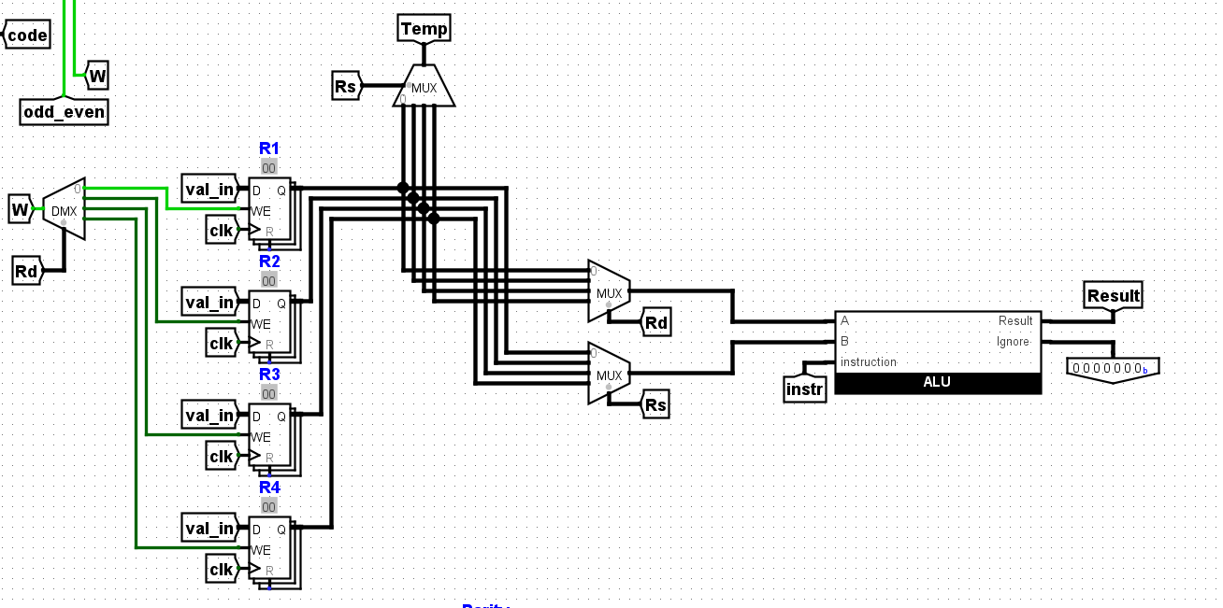

The ALU itself consists of an AU and LU. It receives an instruction code, which it then interprets and performs the requested action. It also receives 2 input values. It should be noted that shifting operations are only performed on values that are fed through the input slot A.

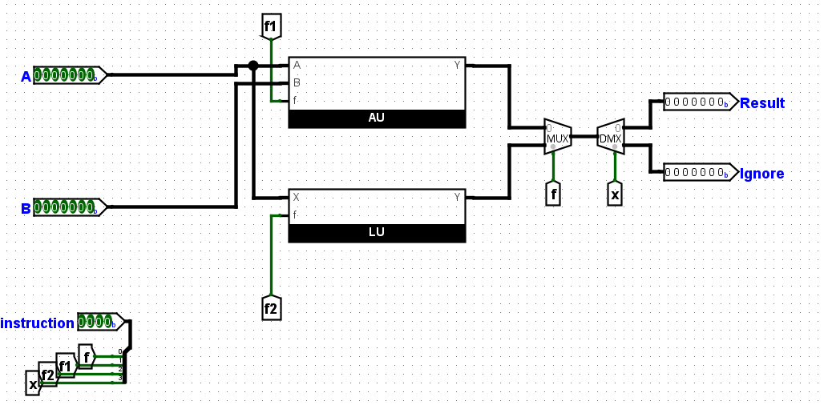
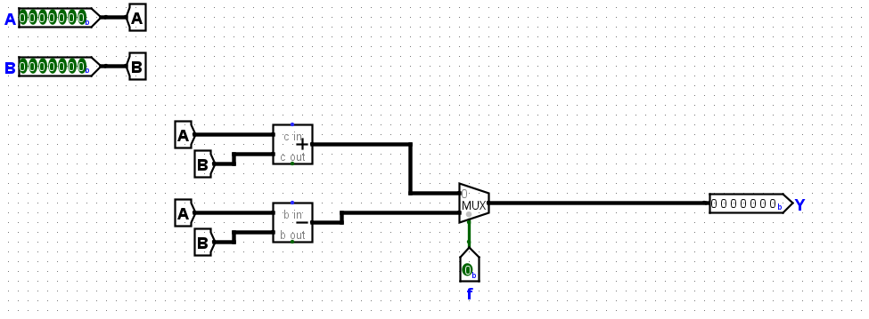
(The AU in ALU)
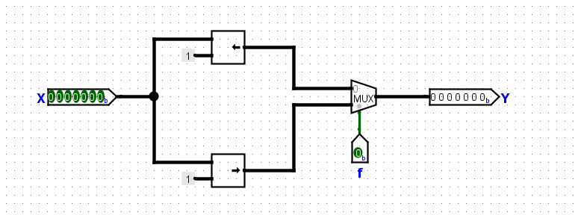
(The LU in ALU)

Finally, we have the parity system. This reads the value stored in the “Temp” tunnel and performs the desired parity check on it, storing the result in an 8-bit register where the MSB is the parity bit.
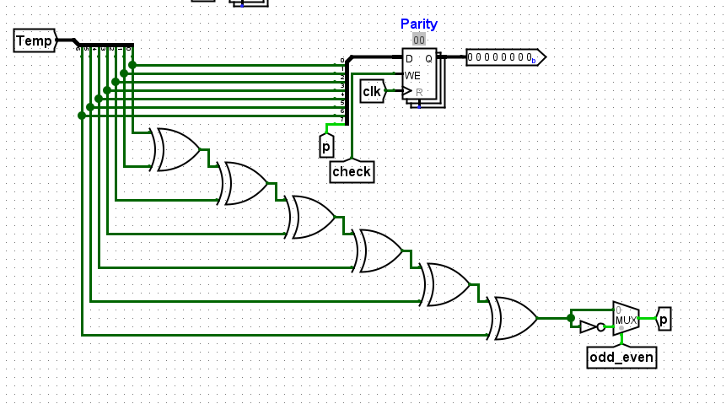

Part III: Instruction Set
The instruction set is slightly complex to set up. Essentially, each hexadecimal digit is broken down into 4 bits, which are then interpreted by the CPU individually to perform tasks that they indicate. Consider the below image:
Here we can see that:
- Bit 0 controls what input value (A or B) should be read.
- Bit 1 controls whether or not an input value should be read at all.
- Bit 2 controls whether or not to perform a parity check.
- Bit 3 acts as a signal to determine whether or not a program has been terminated.
- Bits 4 through 7 act as the ALU instruction code. The codes for these will be mentioned later.
- Bits 8 and 9 together indicate what register is “Rd”.
- Bit 10 controls whether or not to write to “Rd”.
- Bit 11 checks whether to perform an even parity check or odd parity check. This bit only matters if bit 2 is set to 1 .
- Bits 12 and 13 together indicate which value should be fed to “Rd”.
- Bits 14 and 15 together indicate what register is “Rs”.
The ALU instruction codes are as follows:
- “1111” or “F”: Do nothing (ignores the ALU result).
- “0000” or “0”: Add A + B.
- “0010” or “2”: Subtract A – B.
- “0001” or “1”: Shift Left A.
- “0101” or “5”: Shift Right A.

This information can be used to construct code that performs the required operations in the CPU.

Part IV: Instruction Format
Let’s say we want to perform the following operations:
R1 <- 5
R2 <- 7
R1 <- R1 + R2

In this case, we would have to enter the 7-bit binary equivalent of 5 and 7 in input fields A and B respectively, which would give us 0000101 and 0000111. Then we would write the following code into memory:
0010 1100 1111 0000
From the information in the previous section, we know that this line tells the CPU to get the input value A and write it to R1. The hexadecimal equivalent of this instruction is 2CF0 and therefore it is entered into memory at the first location. The next code constructed would be the following:
0010 1101 1111 0001
This code essentially tells the CPU to grab the value from input slot B and write it to R2. The hexadecimal equivalent of this instruction would be 2DF1. We are almost done with the task, the next step is to execute the ALU operation to add the two values, which can be done with this constructed code:
0101 1100 0000 0010
The above code orders the CPU to read the value from R1 and send it to the ALU as its “A” input while also reading the value from R2 and sending it as the “B” input to the ALU as well. With both of these inputs in place and the instruction for adding given to the ALU, the ALU performs the operation and stores the result in the result terminal, which then consequently writes it back into R1 as the instruction indicates. The hexadecimal equivalent is 5C02. We are now done with the operations, the final task is to turn on the “terminated” light, which in the context of this program can be done using:
0101 1000 1111 1010
The above code’s hexadecimal equivalent is 58F0.

Part V: Assembly Programs
With the example of the code constructed in the previous section, we can write a sample program for adding the values of R1 and R2, storing them back into R1 as follows:
2CF0 2DF1 5C02 58FA
The example output of this program is provided below:
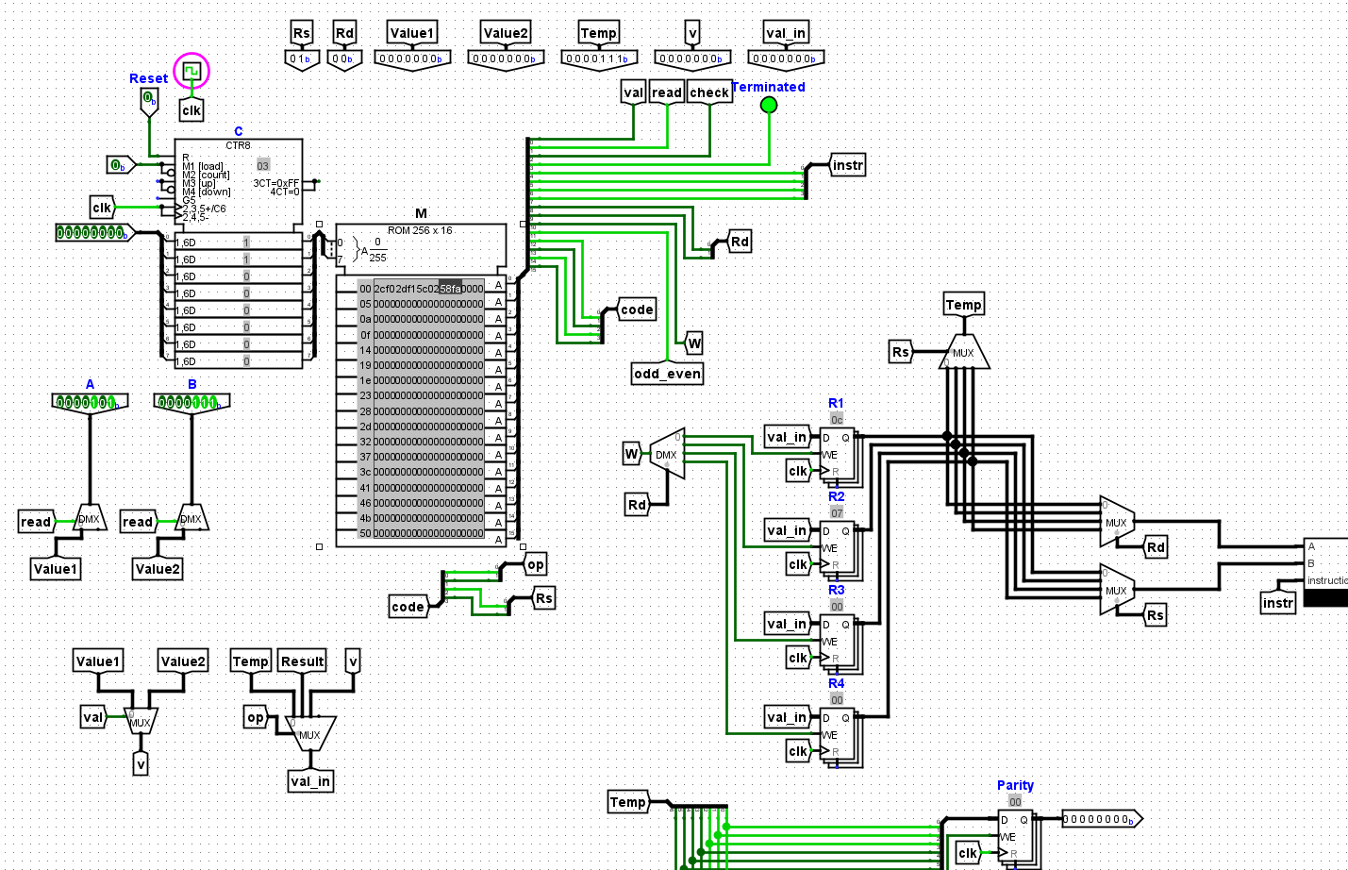

We can see that the value of “0C” is stored in R1, which is 12 in decimal and thus shows that our numbers 5 and 7 did get added and the result was indeed stored in R1.

A similar has also been written for the subtraction of R1 and R2 values.
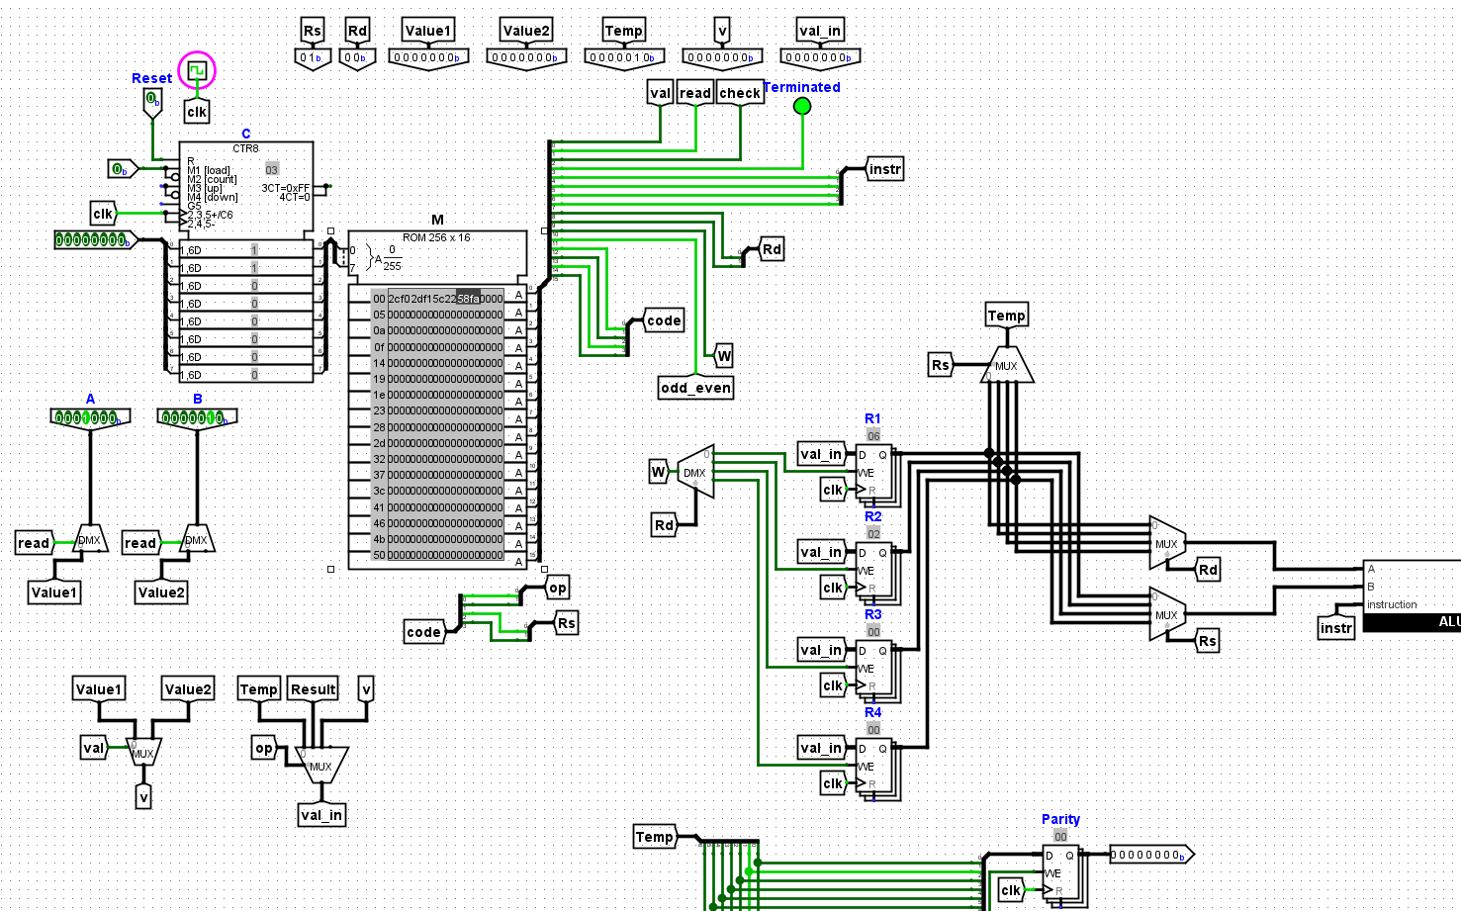
In the above execution, we ran the program with the binary equivalents of decimal values 8 and 2, and 8 – 2 = 6. We can see that the value of 6 is indeed stored in R1 as instructed.
A sample program was written to multiply the contents of R1 by 5.
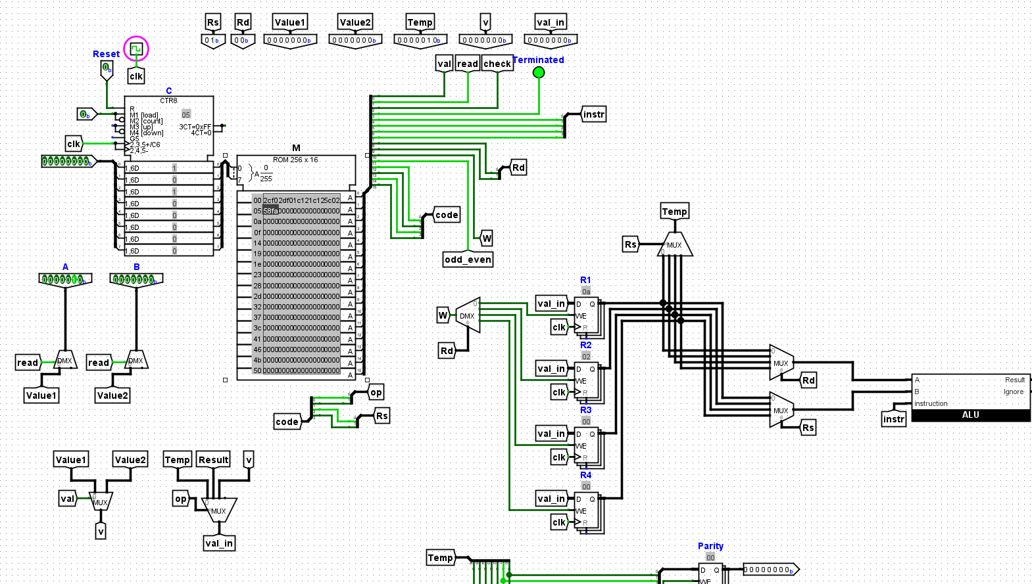
In this execution, R1 was given the value of 2. This value was also stored in R2 to make the multiplication possible. The 2 in R1 was shifted to the left 2 times, thereby multiplying it by 4. To achieve the effect of multiplication by 5, the “backup” 2 was added to the shifted value in R1, which results in the initial value of R1 being multiplied by 5 overall. 2 times 5 is 10, and we can see that “0A” is stored in R1, which is 10 in decimal.

A sample program for division of a number was also written. In this example, R1/8 was performed.
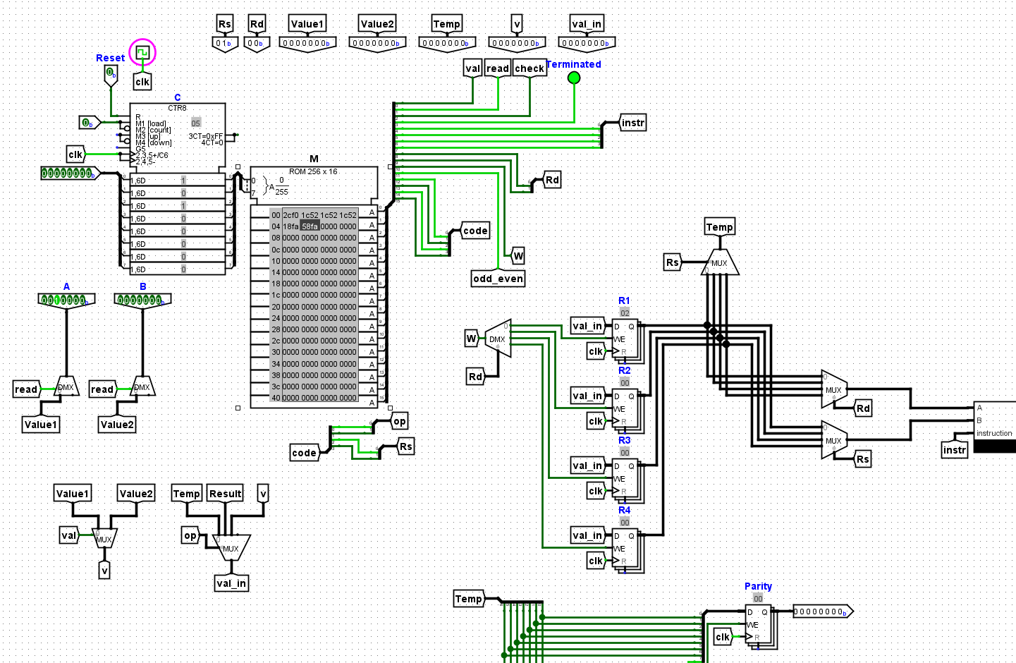
To keep things simple, the number 16 in binary was chosen. It was shifted to the right 3 times to achieve the result of dividing the number by 8 as 2 x 2 x 2 = 8, and so we can see that the result 16/8 = 2 is stored in R1.

Programs for parity checks were also written. Below is a sample program for checking odd parity:
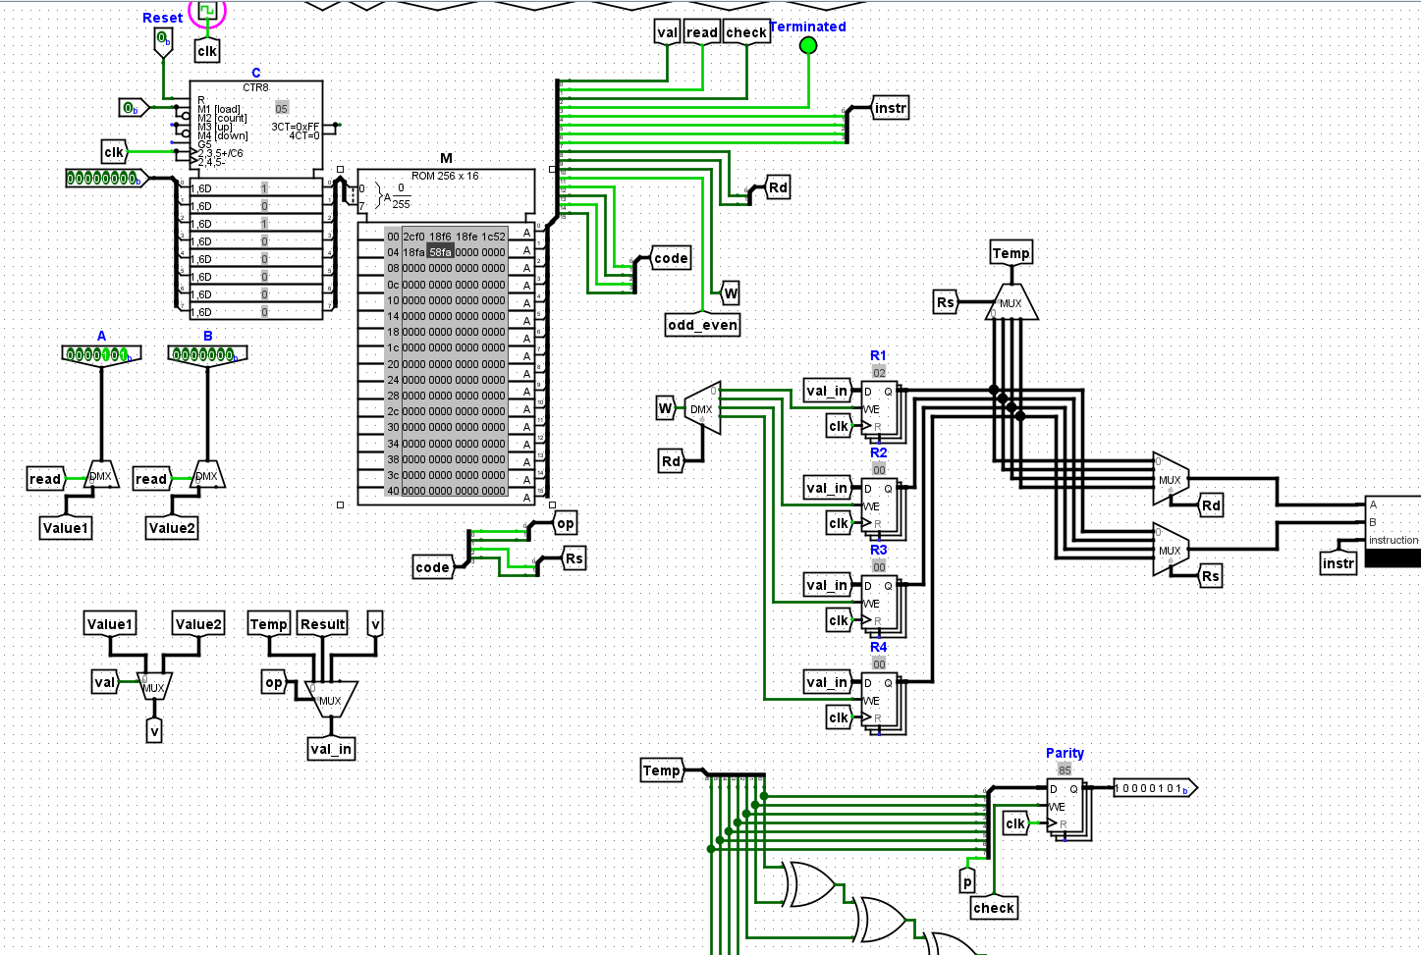
Since the number of 1s is even in the data, an extra 1 is added to the MSB by the parity generator and stored in the parity register.

The program execution for even parity of the same number is shown below:
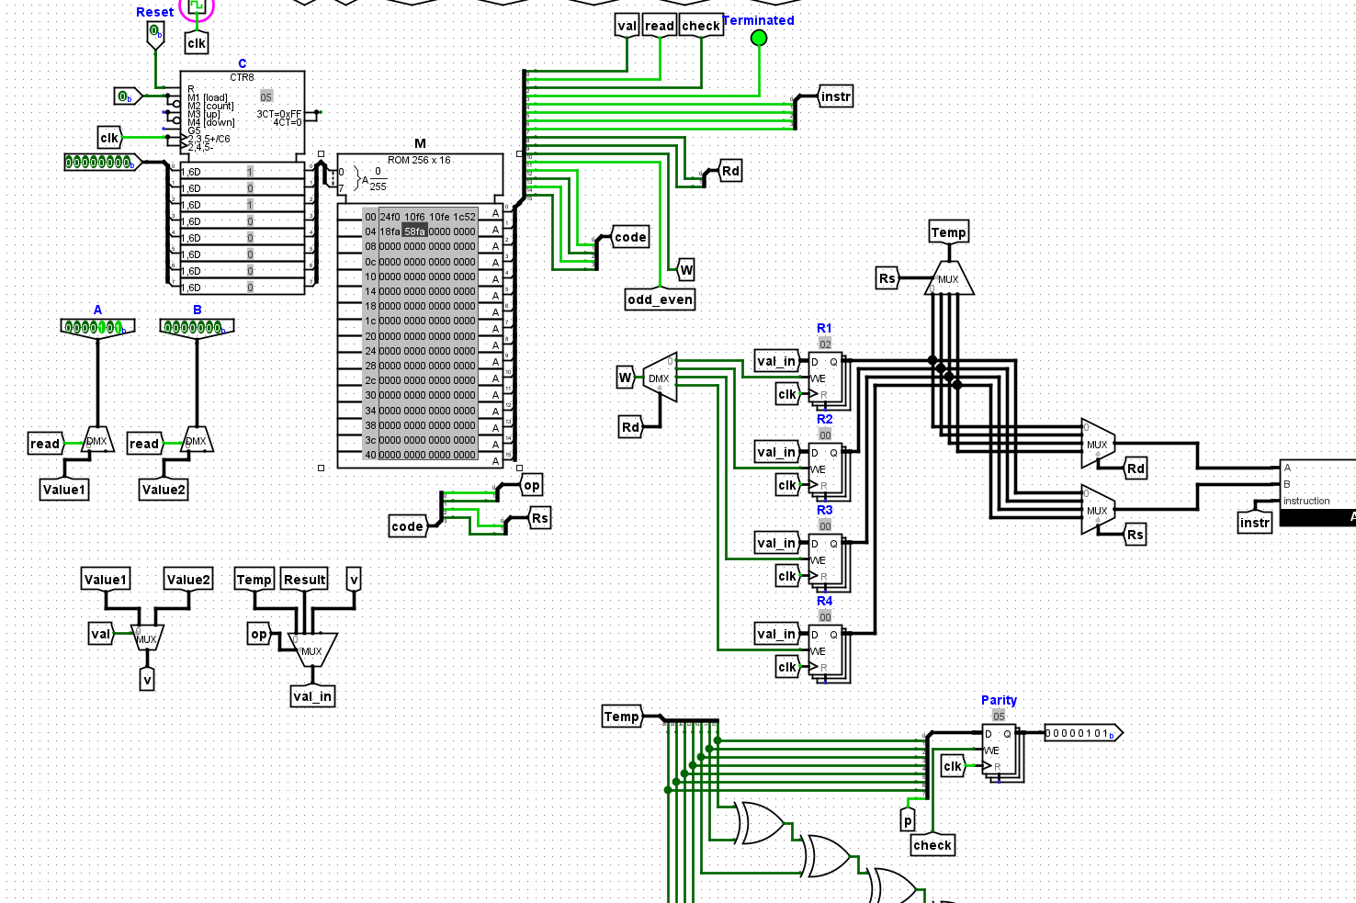

Part VI: Conclusion
To conclude, the CPU is functional in that it is able to perform arithmetic and logical operations. It can also perform parity checks with the specified type of requested parity (even/odd). The main difficulty that was faced whilst implementing this architecture was figuring out how the different components interacted with each other, and figuring out ways to make the instruction codes work with components in a manner that offered large synergies.

